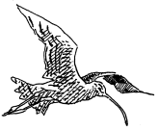

Huddersfield Birdwatchers’ Club

Registered Charity No. 1098296

**NEWSLETTER 2018**

|  |  |
| --- | --- |
| **Contents** | **Page Number** |
| President’s Jottings  From the Recorder  Patch Outings  Indoor Meetings programme  An introduction to your speakers 2018/19  Book Review  Articles  Notice of Annual General Meeting  Subscription form information  Subscription form | 2  3  4  7  8  12  13  18  19  20 |

**PRESIDENT’S JOTTINGS**

The Club continued to prosper, not only because of the committee and report writing team who worked tirelessly behind the scenes, but also due to the continued support of you, the dedicated member. Club membership, due to this remaining relatively stable, has enabled us to function at our usual level. The number of members and invited friends attending the evening meetings, however, has averaged fewer than in recent years. There appears to be no obvious pattern to attendance figures, being as low as 16 and as high as 40 (approximately half the membership). If each member was to introduce a friend to the Club this would, in the long run, guarantee our continued prosperity.

It is with deep regret that I have to inform members of the deaths of two founder members, John Dale and Brian Cocking. John had contributed a great deal to the understanding of ornithology in Yorkshire, whilst Brian had been instrumental in keeping the Club on an even keel from its inception. Obituaries will appear in Birds in Huddersfield 2017.

On a far more pleasurable note, I feel it only correct to mention the monumental amount of work bestowed on the Club over the years by Mike Wainman.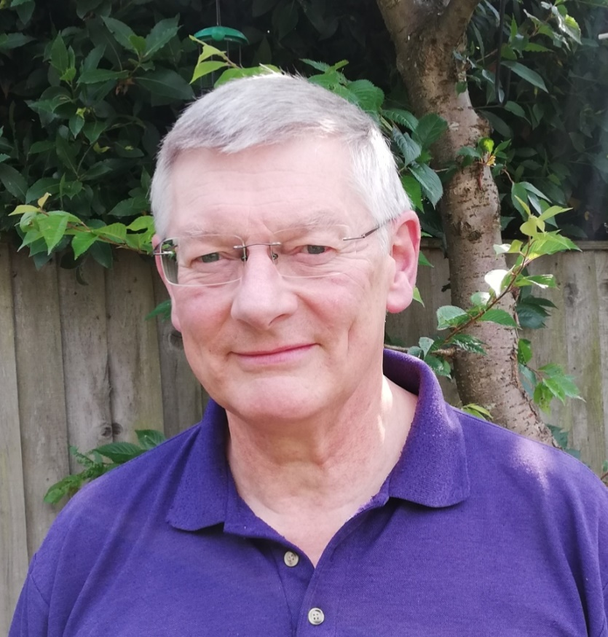 I first met Mike at Blackmoorfoot some seventeen years ago. Little did I know that this fortuitous meeting (for the Club, perhaps not for Mike) would lead to him becoming Honorary Treasurer (2001-2011), Committee Member (2001-2017), President (2012-2015), and Annual Report/book collator (2006-present). Mike was also instrumental in developing the Huddersfield List – this quick reference list is something we have all benefited from since 2003. That Mike is an unsung hero cannot be denied and, although he has

Mike Wainman

retired from officialdom, he continues to collate publications and is a font of knowledge in many things which keep the Club ticking over. Thank you Mike.

For a good number of years the front cover of the Annual Report has been enlivened with an illustration by Stuart Brocklehurst. Over the years Stuart has presented the Club with a copy of the

2

cover to be raffled at our meetings with the proceeds going to Club funds. For reasons unknown,

this did not happen in 2016 but, in 2017, Stuart was kind enough to present the Club with copies of the 2015 (Curlew) and 2016 (Grey Heron) reports. These were raffled separately and raised a total of £102 for Club funds. For continuing to enhance the front cover of our reports with his excellent illustrations and also for supplying a copy for the raffle, Stuart is to be thanked wholeheartedly.

I would like to take this opportunity to reiterate the plea for records which I made last year. It is becoming increasingly obvious that certain species are being under recorded – why are the only Tufted Duck records from Ingbirchworth after mid-June all from Barnsley Bird Study Group? Additionally, why does every Mallard record from Bretton simply indicate the species to be ‘present’? Without members counting and reporting all species we cannot get a proper handle on the species’ population dynamics. Not only does this lack of records make interpretation very difficult for the report writers but it also breaks the continuity which the Club has maintained over the last 50+ years. I have often been asked “Why do we produce an annual report?” My usual answer is two-fold:

1). It is only by analysing and publishing records that we can appreciate what is happening in the natural world – memories fade very quickly.

2). Equally, if not more importantly, is the fact that in years to come these reports will be the only source of information available for people assessing historical distributional records. The only reason we are aware of each species’ past distribution/population is due to dedicated people publishing their findings. Without your records we cannot achieve this. Please don’t fall into the trap of thinking somebody else will be reporting them.

The Newsletter, edited by Hazel Sill, contained a number of articles which members will have found interesting. The Newsletter is the vehicle for all members to have their say, if you have anything to contribute which will be of interest to members please have a word with Hazel.

Mike Denton

**FROM THE RECORDER**

Can I ask that observers who submit records bear in mind the following points:-

1. Site names / Location

Please try to use the names of sites as they appear on the relevant OS map or in the local South and West Yorkshire Gazetteer. If you believe it might be a new site that you are recording from, or new to you, it would help if you could include the OS grid reference. There are frequent instances where different sites across our recording area have the same actual or local name and confusion can and does arise.

2. Counts

If at all possible please try to give counts along with the species record being submitted. Under ideal circumstances accurate counts should be aimed for but I appreciate that is not always possible. That being the case estimation or even "best guess" is preferable to no data at all being supplied.

3

3. Age and Sex

This is helpful if you are able to give it as it puts meat on the bones of the record.

4. Time and Movement

When submitting sightings of raptors and, especially of geese during times of passage, it is of benefit if time and direction of travel can be included in the record as it allows passage through our district to be tracked when other observers of the same individuals also supply the same information.   
 **5. Lastly, if there's anyone else out there fancies doing this job, I'd be pleased to hear from them!**   
  
David Butterfield   
HBWC recorder.

**PATCH OUTING TO LANGSETT 10TH JUNE**

After weeks of clear mornings I woke early on 10th June for the Patch Outing only to find low cloud, I couldn’t even see over the valley towards Totties. The drive to Langsett was no better with headlights on and it was cold as I got out of the car. I was soon joined by John Palliser, Alan Wiggins, Steve Cook, Reg Senior and 2 non-members, Alex Bridger and Samantha Barnsley.

The woods on Langsett Banks were fairly quiet, only hearing Collared Dove, Song Thrush and Blackcap singing as we started our walk. My thoughts were that the mist would have prevented Raptors hunting early so that when the sun finally emerged they would have to be out and we should be able to get good views.

The visibility was so low we couldn’t see the other bank of the reservoir. We heard Cuckoo but had no chance of seeing it on the far side but we managed Grey Heron through the mist and at least two Common Sandpiper. We heard the piping of Oystercatcher several times but no sighting.

The birds seemed to be sparse, something I have written more about in a separate article, but we did see Willow Warbler carrying food and young Coal Tit being fed.

Moving into the Little Don Valley it was still hard work finding birds even though the sun was out by now. I often remark that I never see Dipper here except when I’m on a Patch Outing and again it proved to be the case, seeing a young Dipper on the river. Later we came across Grey Wagtails which we considered to be young.

One great advantage of the Patch Outings is that there are many pairs of eyes and younger and sharper ones than mine too. Sam picked up a Treecreeper feeding up an Oak tree and further investigation by Reg found us a used Treecreeper nest, now unoccupied, but recently used with fresh wool in it.

4

Moving down the valley, no raptors even though we regularly scanned the skyline, the birds were still quiet. No Redstart in the area where I have seen them in previous years. At the vantage point little was evident except a distant Buzzard. A post breeding flock of about ten Lapwing flew west and later another ten were seen. After ages of hard scanning, even trying to convert a rock into something exciting, two of us saw something black feeding on a patch of grass across the valley. Discussion:- me, “Think it’s Ring Ouzel”, Sam “ No I think it has longer legs” Then an adult Red Grouse popped its head up. That settled it; it was a young Red Grouse. I realized then we had been looking at different birds, eventually the other one turned and we had a glimpse of the white gorget of a male Ring Ouzel.

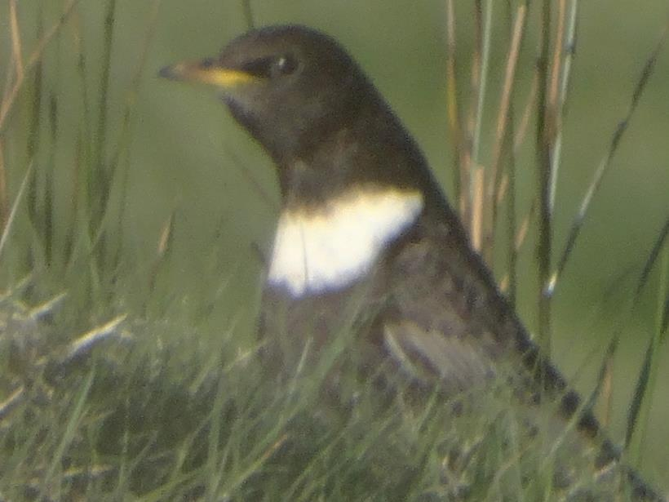

Time to retrace our steps, musing on what we had missed. We scanned a wall to look at a Mistle Thrush we had seen on our way out. We noticed a movement by the wall nearer to us and there was a male Redstart which took off back to the trees with food in its mouth. Reg was slightly behind us and decided to retrace his steps to get a photo. Whilst waiting for him to return Sam called “what’s those?” as four Woodcock flew across and under a tree. Reg returned but no photo of a Redstart but the Woodcock emerged and we all had excellent views of them flying around before returning to the same spot.

By this time there were lots of picnickers, bikers, and dogs off leads and we had given up on seeing anything else. Reflecting that we had not seen or heard any Woodpeckers we decided to look at holes in a dead tree, no sign of birds but in the line of sight some distance away a Great Spotted Woodpecker was feeding in the trees.

In the car park we picked up Pied Wagtail and in discussion with John that we had seen no hirundines or Swifts he looked up and there was a Swallow above us.

All in all a good day, totting up we recorded 39 species; no Chiffchaff, only one raptor, no Swifts or House Martins, Dunnock or House Sparrow but an enjoyable day with good company in a beautiful environment

Thanks to the six who joined me, I think Patch Outings a great experience. I always learn from the others with me and we always see more than I would on my own. Why not try one next year?

CD Abell 11/6/18

5

**BLACKMOORFOOT PATCH OUTING 22ND MAY**

Three members, including the leader, assembled near the inflow channel on the south bank of the reservoir at the allotted time. You should have been here earlier, was the cry from the leader. How many times, as a birdwatcher, have you heard that statement? The morning before the evening ‘patch outing’ had seen two Red Kites and an Arctic Tern at Blackmoorfoot – the evening excursion, however, was somewhat different. Although the weather was in our favour – clear and sunny with a light north-east wind – birds were in short supply, as they had been all spring.

One of the major advantages of regularly working a local patch is that, over time, you begin to get a feel of the numbers of each species which should be about at different times of year. This spring most of the common summer visitors are in very short supply – not only at Blackmoorfoot, but nationally. At present, hirundines and Swift seem to be particularly badly hit. Since 2011, Blackmoorfoot has been famed for its assemblages of non-breeding Sand Martins.

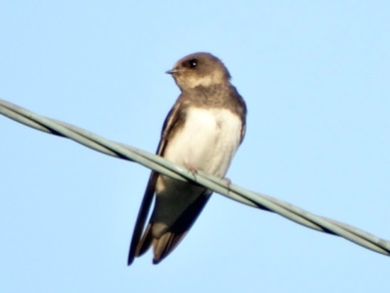

Sand Martin

Following their initial arrival (usually in late March) birds have continued to be seen on a near daily basis until their departure in September (this is the only locality in the Club area, away from the colonies, where this is witnessed). Not this year – birds have only been recorded on 16 dates since the first on 14th March, with no more than a dozen on any one day. There are other species which follow a similar pattern – Wheatear records have been virtually non-existent this spring and Swallow, House Martin and Swift are all down on previous years. The reason behind this anomaly, although as yet unknown, is nonetheless worrying.

In an effort to find birds, we visited Orange Wood. A good selection of birds were still singing – Chiffchaff, Willow Warbler, Whitethroat, Chaffinch, Blackbird and Song Thrush (but no Blackcap). A Mistle Thrush was seen collecting food and birds already known to be breeding, Great Spotted

6

Woodpecker and Nuthatch, put in an appearance, the latter feeding young in the nest.

A visit to the nearby Will’s O’ Nat’s public house brought the evening to an eventful end. Although there had been few birds, the pint of Guinness and a whisky were greatly appreciated.

Mike Denton

**INDOOR MEETINGS 2018 - 2019**

Indoor meetings are the main social activity of the club and create a focus for information and dissemination of club news, as well as providing the opportunity to listen to talks presented by a host of experts. The 2017-18 season saw healthy attendances even during the depths of winter and occasionally competing with the attractions of Huddersfield Town’s exploits in the Premier League (long may they continue) with an average of just fewer than 30 members at each. Those attending were treated to topics as varied as an adventure in Botswana and the perspective of birding from home, albeit that home is perched on the heights of the Pennines. We heard about the changes that can be encountered through spring at different latitudes, the joys of South Florida and North Norfolk; Southern Africa and South-East Spain; Indonesia; and America’s Northwest. The more technical topics educated us about wildfowl, green birding, the role of bird observatories, together with field craft and photography. As always, the lecture year culminated once again with a review of our own Huddersfield birding in 2017. The lectures all stimulated discussion and the attendances are encouraging but, as always, only you the members can tell us whether we are doing the right thing: feedback of all types is welcomed.

As in previous years we were treated to presentations from some of our own members, which always prove to be a satisfying feature, and these have shown themselves to be very popular; this year we have fewer home-grown contributions, but we expect them to be just as well received. There is a varied set of lectures to tempt you with, incorporating a notable Yorkshire theme this year as well as some more exotic offerings and we hope that something amongst the 14 on offer will be of interest to everyone. We do know that some members find it quite difficult to attend through personal commitments, geography, timing etc. but would encourage everyone to make that extra effort. You really would find it to be worthwhile.

**LECTURE SCHEDULE 2018-19**

|  |  |  |  |
| --- | --- | --- | --- |
| 2018 | Sept 4th | Craig Ralston | The Lower Derwent Valley |
|  | Sept 25th | Dave O’Hara | RSPB Dove Stone – Birds, Bogs and More |
|  | Oct 9th | Rob Adams | Spurn – A Magical Place |
|  | Oct 23rd | Tim Melling | Wildlife Photography Around the World –  Equipment, Techniques and Field craft |
|  | Nov 13th | AGM & David Sill | The Pennine Garden (Slight Return) |
|  | Nov 27th | Paul Rogers | Iceland – Guillemots, Goldeneyes and Gyrs |
|  | Dec 11th | David Tolliday | UK Travels With a Wildlife Camera |
|  | Jan 8th | Julian Sykes | Jordan – Not Just Petra |
|  | Jan 29th | Laurence Rose | Perspectives of India |
|  | Feb 12th | Alf King | A First Taste of Ecuador |
|  | Mar 5th | Ian Robinson | Pheasants and Cranes in Manchuria |
|  | Mar 26th | Jeff Clarke | Inspiring Avians |
|  | April 9th | Gary Prescott  (The Biking Birder) | Peruvian Birds and Adventures |
|  | May 7th | Mike Denton | 2018 – A Huddersfield Birding Year |

**OUR SPEAKERS THIS YEAR**

**Craig Ralston** – Craig is a senior reserve manager with Natural England and this will be his first visit to the club. He has been watching and monitoring birds in the Lower Derwent Valley since 1982 and has amassed a site list of 237 species, which is quite remarkable. He first became associated with Natural England (then English Nature) at the site in 1993 and has remained connected with conservation work there ever since; truly an expert on the area.

The Lower Derwent Valley is one of the North of England’s premier birding sites embracing Wheldrake Ings, North Duffield Carrs and many other areas which offer interest to the birder all year round, and with its special feature of waterbirds during the winter. Craig will reveal some of the secrets of this special area in his talk, simply entitled “The Lower Derwent Valley”.

<http://yorkbirding.org.uk/sites/lower-derwent-valley/>

**Dave O’Hara** – Does everyone know that the Huddersfield Birdwatching Club area actually has its own RSPB reserve, and not a tiny one at that? Dave O’Hara is the site manager at Dove Stone, having honed his skills over many years within the RSPB at other sites in their portfolio. Not only is he the manager at “our” reserve but also lives within the Huddersfield area where he is a frequent and active birder. He will enlighten us about the hard work that has gone into the continuing development work as well as it’s mysteries and secrets in “RSPB Dove Stone – Birds, Blogs and more”.

<https://www.rspb.org.uk/reserves-and-events/reserves-a-z/dove-stone/>

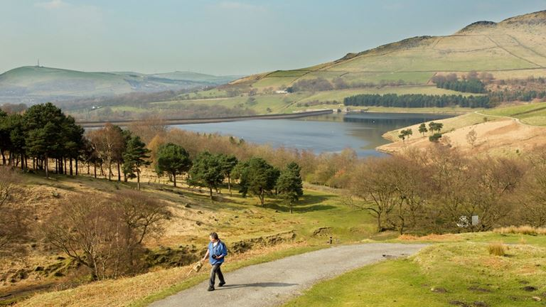

DOVE STONE RESERVOUR

**Rob Adams** – most of us will be aware of the allure of Spurn and its surrounding areas. Probably fewer of us know about the Spurn Observatory and the work that is undertaken there to harvest data and provide a welcoming environment for visiting birders. Rob is the Chairman and Treasurer of the Spurn Observatory as well as being an advocate for all that they provide. Be prepared to get drawn to the temptations of the place once again when hearing him talk on “Spurn – A Magical Place”

<https://www.spurnbirdobservatory.co.uk/>

**Tim Melling** – a deservedly popular speaker at club meetings over the years Tim brings his unique brand of bubbling enthusiasm combined with encyclopaedic knowledge of all wildlife to enliven every meeting that he addresses. He is a Senior Conservation Officer with the RSPB, based at Denby Dale, with widespread responsibilities for a range of projects throughout the North of England. In addition he also acts as a tour leader for Nature trek to many far-flung places, not least the Americas.

Tim takes a host of mean photographs, which are achieved more by judgement than luck, and will share with us some of the secrets and techniques behind capturing those images. Don’t for one minute imagine that this will be a dry technical presentation: even for those with no keen interest in photography there will be a host of photographs and accompanying tales to keep everyone

9

entertained. “Wildlife Photography Around The World – Equipment, Techniques and Fieldcraft”.

<https://www.flickr.com/photos/timmelling/>

**David Sill** – David is one of the club’s more experienced birdwatchers and, in particular, loves the high grounds of Yorkshire with their ever-changing patterns of bird movements. As an indulgence of that love he lives with Hazel in a truly remote location above Marsden where he gains an exceptional perspective of birding in the club area. Last year he shared some insights into birding from his Pennine garden and this year expands upon that theme with “The Pennine Garden (A Slight Return)”.

**Paul Rogers** - Paul is a most popular presenter to the club having delighted us on many occasions before with a diversity of topics. He has had a life-long interest in natural history, which is underlined by his qualifications in Ecology and Animal Behaviour gained at London University and he is a principal leader for Ornitholidays, having led over 210 tours. For some time now he has had the pleasure and privilege of living at Shorelands on Anglesey, the former home of wildlife artist Charles Tunnicliffe. He is widely travelled in Europe, North America and Africa and lectures on ornithology, ecology and all aspects of natural history.

One of Paul’s favourite places to visit is Iceland. Whilst it doesn’t offer a long list of exotic species it does feature some spectacular and mouth-watering species about which he will delight us in “Iceland – Guillemots, Goldeneyes and Gyrs”.

**David Tolliday** – David is making a welcome return to the club visiting for the third time from his base in Cheshire. He is a wildlife photographer having been interested in wildlife for as long as he can remember with one of his first wildlife memories being of a flock of Lapwings in a field at Cuckmere in Sussex when he was about ten years old. He was transfixed by these beautiful birds and they continue to remain one of his favourite species. His presentation will feature not just images but soundtracks of British wildlife in “UK Travels with a Wildlife Camera”.

<http://www.davidtolliday.co.uk/>

**Laurence Rose** – Laurence has worked for the RSPB, from which he has recently retired, for over 30 years in a variety of roles including Regional Director, Northern England Region and, most recently, Strategic Project Manager based in Denby Dale. He is also a composer and writer, a Director of CoMA - Contemporary Music for All, a former Director of the Huddersfield Contemporary Music Festival and a business adviser to arts and conservation organisations. He edits the web site The Natural Light <http://www.naturemusicpoetry.com/> which explores the connectivity between the arts and nature. This year Laurence will entertain us with his “Perspectives of India” embracing both the culture and birdlife of this fascinating country.

**Alf King** – Alf is the indoor meeting organiser and responsible for the offerings that are being laid before you this season; he is also the club’s IT slave. He has been fortunate over the years to be able to visit many countries to enjoy their birds and culture. One that he did visit for the first time in 2017 was Ecuador and this presentation will give you a flavour of what to expect from the bird-rich country.

10

**Jeff Clarke** – Jeff has presented to the club on previous occasions and his return is sure to be popular. He has a passion for the natural world and loves sharing that enthusiasm with as many people as possible. As an environmental educator with 26 years of experience he brings innovation, inspiration and fun to lessons. He is an Associate Tutor for the FSC and leads wildlife holiday tours both independently and in partnership with other organisations.  
  
Jeff is often asked “What is your favourite bird?” This talk was created in response to that question and is all about those charismatic birds that capture the imagination and explores their life stories to try and work out what it is that gives them ‘The Edge’!

<http://www.jeffclarkeecology.co.uk/>

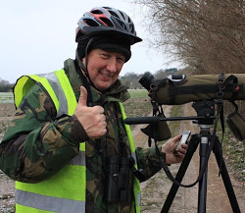**Gary Prescott** – Gary goes by the name of “The Biking Birder” and refers to himself as “A UK Green birder, birdwatcher, twitcher and environmentalist”. He is a retired special needs teacher who now devotes himself to a wealth of environmental and birding projects, often through the medium of long-distant bike rides, of which he is also passionate.

Following his first visit to the club, when he introduced us to the delights of “Green Birding” Gary embarked upon an odyssey in Peru where he has cycled and kayaked the length of the country. Hear all about this and his encounters along the way in “Peruvian Birds and Adventures”

<http://bikingbirder2016.blogspot.co.uk/>

**Julian Sykes** – Julian hails from Huddersfield, then moved to Spain where for many years he headed up his own tour company based in Valencia and has since returned to his hometown. He has been interested in nature and the natural world all of his life and says that he has had the good fortune to be able to combine his love of wildlife & experience as a guide to develop and lead a wide range of holidays. Since starting his operation in Spain as a professional wildlife guide several years ago he has developed an excellent reputation for 'value for money' holidays and short breaks always conducted with a high level of professionalism and good humour. He also acts as a main guide for Speyside Wildlife.

The country of Jordan is renowned for its architectural delights but, for the birder, it offers even more. Learn about this in “Jordan – Not Just Petra”

<http://www.juliansykeswildlife.com/index.html>

<http://www.speysidewildlife.co.uk/The_team.aspx>

11

**Ian Robinson** – Ian returns to the club with another of his fascinating and immensely popular talks. He is an intrepid and enthusiastic traveller, birder and photographer who has visited more countries than any of the rest of us might imagine, yet he doesn’t keep a life list. Ian lives in Filey and is one of the founder members and a continuing stalwart of the Filey Bird Observatory and Group.

Ian will tantalise us once more with oriental exotica in “Pheasants and Cranes in Manchuria”.

<http://www.fbog.co.uk/>

**Mike Denton** – our own President Mike Denton should need no introduction; to say that he is a bedrock of the club would be an understatement and he is, of course, one of the very few surviving members of the club since its establishment in 1966. Once again Mike will be rounding off the presentation year with a review of the key sightings from 2017 coupled with photographs of birds in the club area taken by members and other local birders, in “2017 – A Huddersfield Birding Year”.

**BOOK REVIEW**

**S. L. Mosley and The Birds of the Huddersfield Area**

Members may recall this iconic book, published in 1915, and that for the Club’s 50th anniversary we had planned to re-publish it. However, the specialist firm with which we were dealing went into liquidation and the project faltered. Mike Denton’s epic book *A Natural History of Blackmoorfoot Reservoir, Huddersfield* became our anniversary project instead and sold very successfully.

However, the idea was not forgotten and, thanks to the generosity of the owner, we have now been given access to a complete copy that is being taken apart and re-bound. We have invested some Club money to have the pages scanned professionally, with a view to recreating it as an ‘e-book’, i.e. a version that can be viewed and, if desired, downloaded from our website. This will show all the original pages, warts and all, with Mosley’s idiosyncrasies and will be accompanied by an introduction about Mosley and the book’s significance. The aim is to make the book, which is an important landmark in both local and national avifauna, known and available to a wider audience, as part of our charitable remit.

More details when we launch the book, probably early in our new lecture season.

Mike Wainman

12

**TYPICAL BIRDWATCHERS – LOOKING THE OTHER WAY**

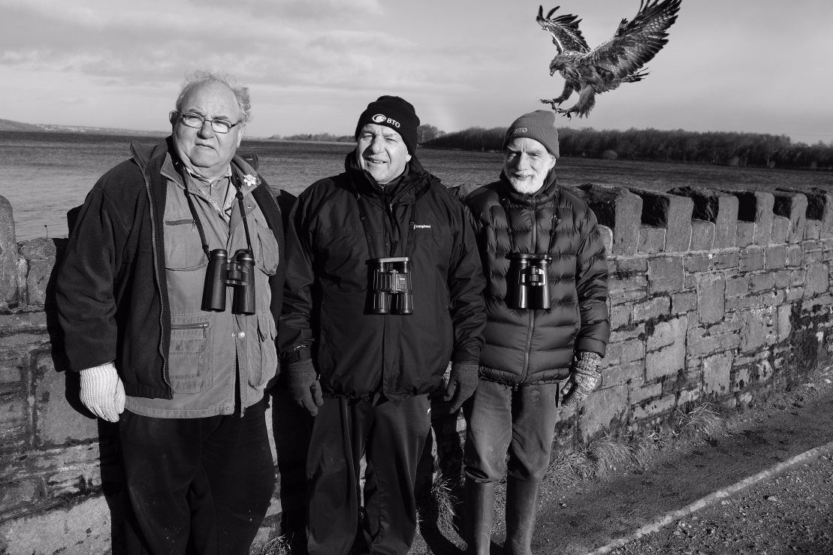

Although a total of 219 bird species have been recorded at Blackmoorfoot Reservoir, the three Club members in the photograph above (taken by a local resident, Gavin Scott) were totally oblivious of the eagle *Aquila* sp. above their heads. The photograph shows, from left to right, Trevor Wimpenny, Glynn Silver and Mike Denton, at their favourite watching point on the south bank of Blackmoorfoot Reservoir.

There are several fitting captions, some not printable, which could accompany the shot – The Three Musketeers – Which ones Compo? – The Good, the Bad, and the Ugly – Small, medium and large. I’ll let you decide.

**A CONSERVATION PROJECT IN SICILY**

In April I visited three reserves in Sicily: Torre Di Vendicari, Saline di Priolo and the Pantani Cuba and Langarini. The first two were close to the sea, Saline di Priolo being on former salt flats and had become a landfill site. It was close by the Magnisi peninsula where Stone-curlew and Calandra Lark are found and both these reserves had abundant bird species.

For this article, however, I am focusing on the third site in the southeast which has two large lakes, Cuba and Langarini, separated by a road.

13

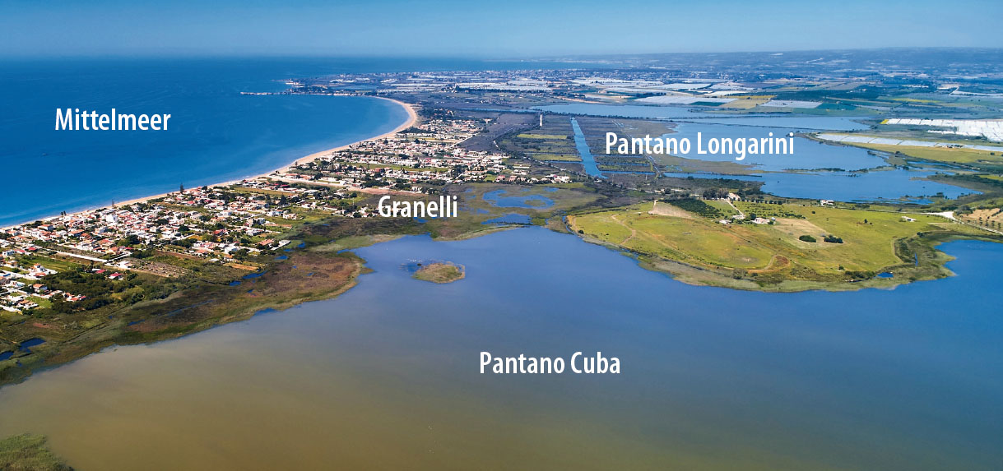

A German Foundation, the Stiftung Pro Artenvielfalt (Foundation Pro Biodiversity) or FPB has for 15 years been working to protect nature and biodiversity through land purchase and habitat management across Europe and has financed projects in Sardinia, Cyprus and Malta to stop illegal bird slaughter on migration routes.

The Cuba and Langarini project, funded by the FPB, is to secure a major migration staging post where fishing and shooting everything, including Greater Flamingos is common. The site is around 1,360 acres of wetland habitats with meadows and olive and citrus groves. Four years of hard work by a small group of local birders saw 150 cu. metres of rubbish removed including polytunnels, asbestos and tyres. Hundreds of trees have been planted and a wonderful habitat with around 7 kilometres of path has been created despite confrontations with hunters. There is much more to be done and funding was being sought for a 7 kilometre fence around Langarini.

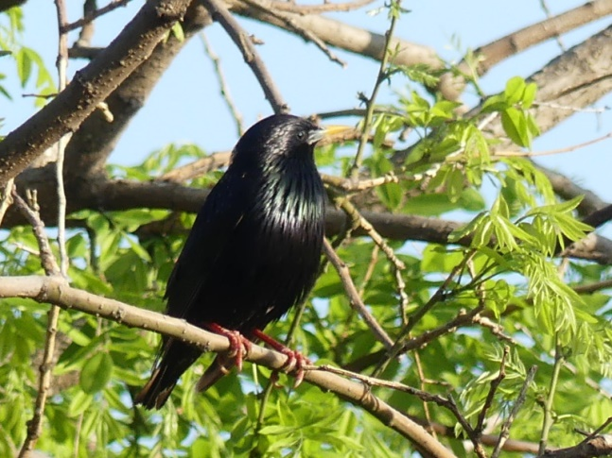

The checklist is of 240 bird species, 23 dragonfly and 9 wild orchid species plus many butterflies. I was told March is best for migration and July for thousands of waders.

The gate to the reserve is kept locked and to visit one has to book ahead and one of the English speaking guides will be delighted to show you around. Contact by: contact@spa-it.org

Spotless Starling

Highlights for me were Golden Orioles, a Wryneck, Pallid Harrier, Ferruginous Duck, Richard's Pipit and a flock of 15 Yellow Wagtails.

Stephen Cook 14

**WHERE HAVE ALL THE BIRDS GONE?**

Is it me? Am I getting old? Am I going blind? Am I going deaf?

Yes all these descriptions apply but I am sure there is more to it than that. I feel certain that bird numbers are down this year. For example I saw the first Swift of the year on 20th May and have rarely seen any since except on the Norfolk coast.

As ever I have let events distract me from doing the birdwatching I would wish, but since April I have been in good habitats like Nidderdale, Inner Hebrides and the Peak District as well as Cheesegate Nab and Langsett locally, and keeping notes of sightings from my house and garden.

The question of bird numbers came home to me quite forcibly whilst in the Peak District, where I spent three days in early May leading a birdwatching holiday in such promising locations as Lathkill Dale and Padley Gorge. I have led a similar holiday 9 times in May, using more or less the same locations. But this year I had the feeling that numbers were lower. Unfortunately I couldn’t count actual numbers, but I have species lists of each visit to look back on.

For example with 7 pairs of eyes looking for birds in excess of 30 hours, no Lapwings were seen. No Woodpeckers or Cuckoo even heard. No Swifts or Sparrowhawk. Frighteningly two sites where House Martins have bred in previous years, none were present, with no sign of fresh nests. They were only seen once, a small group flying high over Dove Dale. There were hardly any waders at Carsington. Other expected species missing included Common Sandpiper, Stonechat, Spotted Flycatcher and Linnet.

This brings me to my first question? Has anyone else noticed a similar decline? Better still do we have quantitative records to demonstrate this? Alarmingly I feel that the forecasts of environmental disaster are getting nearer to fruition. Is Climate Change beginning to have a real detrimental effect? I understand that certain species like Montagu’s Harrier have been affected by weather conditions in the Sahara and presumably this has affected many other migrant species. Birds that have been tagged have made repeated efforts to cross the desert, but have turned back, and had not made it into North Norfolk by late May. To my second question I don’t think it is all down to my incapacities, as I was accompanied by eyes sharper than mine and hearing more acute. After all in the Peak we did manage to find a male Ring Ouzel visiting a nest site, and a probable Peregrine breeding site.

I hope you don’t think I’m all doom and gloom. There were some positives in perceived increased numbers of Redstart in Lathkill Dale and Pied Flycatchers seemed more numerous in Padley Gorge. After all we have had very odd weather patterns this spring, and the wild flowers were magnificent. I just hope that the strange weather this spring is the cause of the variance. I would hate to think that future generations will miss out on the beauty of our birds and suffer the consequences of environmental damage.

CDA May 2018 (Chris Abell)

15

**REED BUNTINGS AT WARDS END FARM** (David W. Sill)

Reed Buntings are regular visitors to our garden, one or two pairs breeding in the immediate vicinity, but throughout the winter months are the commonest visitors to the seed we put down. I have carried out daily counts for the last five years and tabled the results for the principle months giving the number of birds/days per month.

We get very few Reed Buntings on visible migration watches but some small numbers are usually seen from October. As can be seen from the table, numbers usually increase significantly after the turn of the year, probably augmented by wintering continental birds. The obvious exception to this being 2016/17 where there is much more autumn activity with birds apparently moving through with only a small number remaining to the winters end.

|  |  |  |  |  |  |  |  |
| --- | --- | --- | --- | --- | --- | --- | --- |
| Winter | Oct | Nov | Dec |  | Jan | Feb | March |
| 2017/18 | **32** | **36** | **141** |  | **292** | **350** | **533** |
| 2016/17 | **178** | **151** | **101** |  | **66** | **40** | **43** |
| 2015/16 | **20** | **13** | **1** |  | **56** | **119** | **150** |
| 2014/15 | **49** | **8** | **40** |  | **70** | **65** | **109** |

What prompted this piece was the relatively exceptional numbers of birds in early 2018. The winter started innocuously without much of a hint of what was to come, but numbers rose steadily and it became obvious that we were in line for some harsh conditions from Siberia. By February the ‘Beast from the East’ arrived and we had temperatures down to - 0.7 Centigrade and blizzard conditions. Where the birds were roosting is not clear but they would arrive shortly after first light and remain with constant comings and goings throughout the day.

Daily double counts were had through March, with a maximum of 32 on the 17th which happened to be the day that the ‘mini-beast’ arrived.

What little shelter was available was low down in the deciduous hedge which wasn’t much, and on one occasion one individual hollowed out a depression in the snow to shelter in until the blizzard had passed some 20 minutes later.

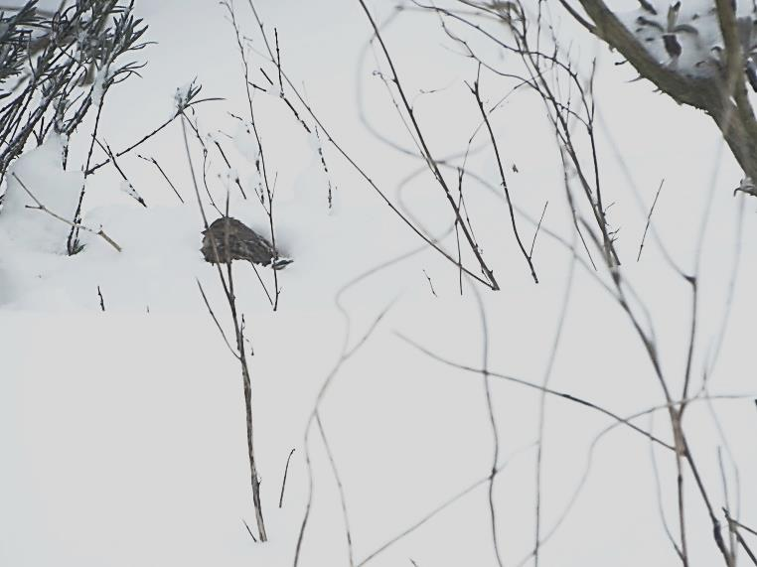

16

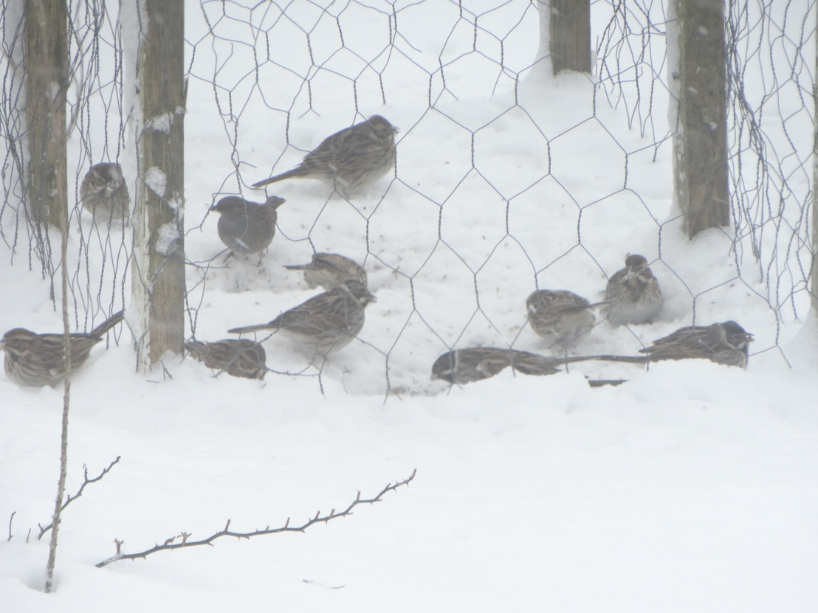

February 2018

**Unusually there were good counts throughout April too, with 19 on 10th, and good numbers even persisted into early May, much later than the norm, with a max., of 13 on 1st.**



17

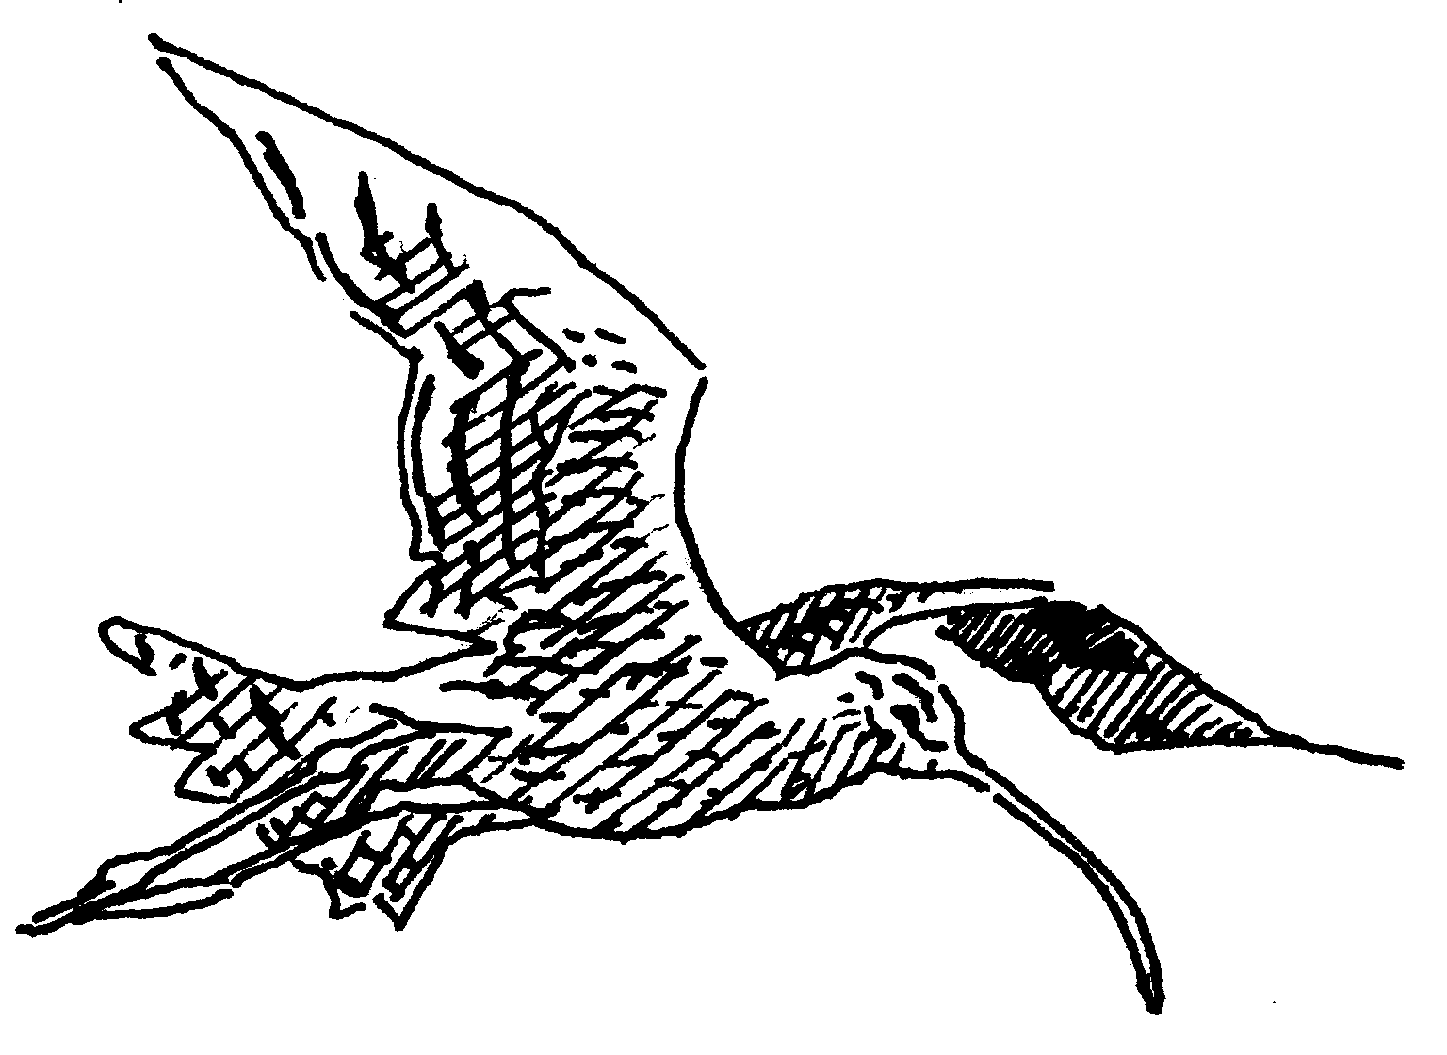

**Huddersfield Birdwatchers’ Club**

Chris Abell, Secretary, 57 Butterley Lane, New Mill, Holmfirth HD9 7E

Tel 01484 681499; email [cdabell@gmail.com](mailto:cdabell@gmail.com)

**NOTICE OF ANNUAL GENERAL MEETING**

The 52nd Annual General Meeting is to be held in Huddersfield Town Hall at 7.30pm on Tuesday 13th November 2018.

A full agenda will be published on the Club Website before the meeting.

The following posts are due for election to serve for 2 years;

* Secretary
* Conservation
* Recorder
* 3 Committee Members (4 if MD elected in Conservation Role)

Nominations for these posts should be sent to the Secretary, in writing or by email, 14 days before the meeting (i.e. to be received no later than 30th October)

C D Abell 20/6/18

18

2018/2019 SUBSCRIPTIONS NOW DUE!

Please send your subs now either:

To our Membership Secretary Hazel Sill by cheque using the slip overleaf or:

By bank transfer (BACS) directly to the club account which is:

Huddersfield Birdwatchers’ Club, HSBC, sort code 40-25-10, account no. 40462195

(Please remember to put your name in the reference box and email Hazel to confirm that you have paid)

The Club receives substantial amounts in Gift Aid. Most members have already signed a Gift Aid form and it will still be valid. However this year I am once again updating the membership list, and would like to check that you are still a taxpayer, if you are would you mind signing the form overleaf as it would help me so I don’t have to get in touch with everyone and ask each one personally. It costs you nothing and the Club can reclaim a tax rebate from the government.

Also this year to conform with the Data protection act the form opposite needs to be signed by you to allow us to hold some of your personal details, so along with the above please send it in with your subs.

Hazel Sill’s contact details: Address-: Mrs. Hazel Sill

Wards End Farm, Marsden, West Yorks. HD7 6NJ

Email [hazelsill@hotmail.com](mailto:hazelsill@hotmail.com)

Tel. No: 07854739646

19

-------------------------------------------------------------------------------------------------------

**HUDDERSFIELD BIRDWATCHERS’ CLUB**

**SUBSCRIPTION RETURN 2018/2019**

|  |
| --- |
| **Title: Forename(s): Surname:** |
| **Address:** |
|  |
|  |
|  |
| **Post code: Tel. No (inc. STD code):** |
| **Email address:** |
| **Date of Birth (u18s only): Amount £** |
| **Gift Aid**: If you pay UK income or capital gains tax, you can help the Club reclaim tax from the government on your membership subscription or donation, at no extra cost to you. As a charity, the Club will then receive an additional 25p for each £1 donated. **Simply tick the tick the Gift Aid box below.**  **Note: 1**. For couples holding joint membership, a separate form is needed for each taxpayer - simply copy this form or ask for an additional form if this applies. If only one is a taxpayer, they should complete a single form **2**. You must pay income or capital gains tax of at least the amount of tax the Club reclaims on your donation. **3**. You must tell us if you change name or address, cease to pay tax or wish to withdraw this declaration. **4**. If you pay tax at the higher rate, you may claim further relief in your Self-Assessment tax return. |
| **I wish the Club to treat as Gift Aid all subscriptions/donations I make from this date (tick):** |
| **Data protection**: By filling in this form you are agreeing to Huddersfield Birdwatchers’ Club holding your personal details. Please sign below to confirm your agreement to HBWC holding your data and using it to communicate with you and for the proper management of the Club.  The data you provide is for the sole use of Huddersfield Birdwatchers’ Club and will be kept private. This data is kept for communication purposes with you as members and we will not pass on your data to any third party except as required for Gift Aid and other legal requirements.  **It is important for every member, no matter how long-standing, to complete this form in order to comply with new legislation. We can no longer administer your membership or contact you to renew without this permission.** |
| **Signed: Date:** |